**Coding Assesment-2**

**Career Hub, The Job Board**

Tasks:

1)Provide a SQL script that initializes the database

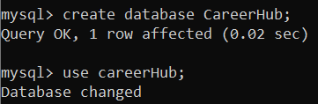

3. Define appropriate primary keys, foreign keys, and constraints.

Appropriate primary and foreign keys are defined.

Company_Id int primary key,

Job_id int primary key,

Applicant_Id int primary key ,

Application_Id int primary key,

foreign key (Company_Id) references Companies(Company_Id));

foreign key (Job_Id) references Jobs(Job_Id),

foreign key (Applicant_Id) references Applicants(Applicant_Id));

2. Create tables for Companies, Jobs, Applicants and Applications.

create table Companies (

Company_Id int primary key,

Company_Name varchar(100),

Location varchar(200));

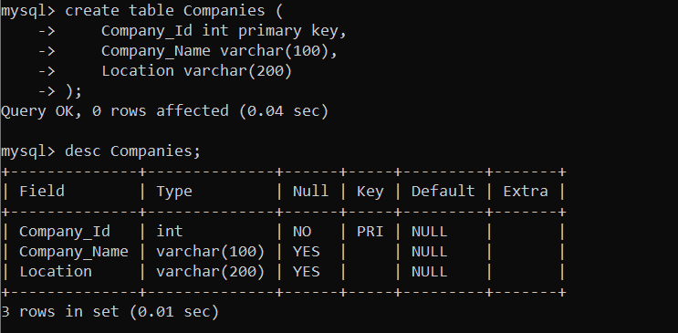

create table Jobs (

Job_id int primary key,

Company_Id Int,

Job_Title varchar(100),

Job_Description Text,

Job_Location varchar(100) ,

Salary decimal(10, 2),

Job_Type varchar(50),

Posted_Date datetime,

foreign key (Company_Id) references Companies(Company_Id));

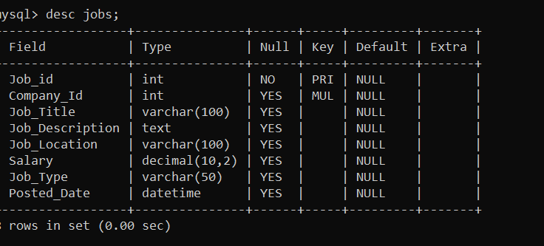

create table Applicants (

Applicant_Id int primary key ,

First_Name varchar(50),

Last_Name varchar(50) ,

Email varchar(100),

Phone varchar(20),

Resume text);

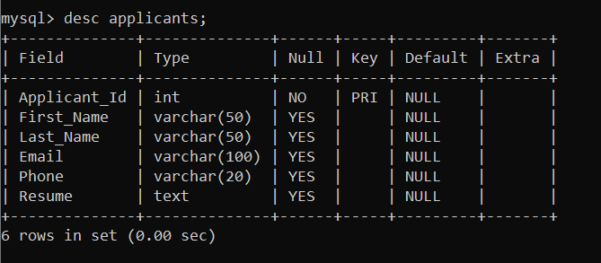

create table Applications (

Application_Id int primary key,

Job_Id int,

Applicant_Id int,

Application_Date datetime,

Cover_Letter text,

foreign key (Job_Id) references Jobs(Job_Id),

foreign key (Applicant_Id) references Applicants(Applicant_Id));

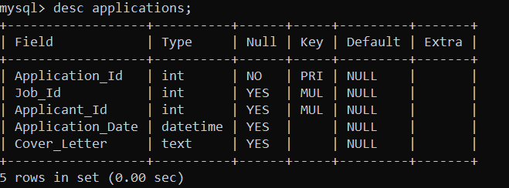

Insert values into the Companies table

insert into Companies (Company_ID, Company_Name, Location)values

(1, 'Battle Technologies', 'Bangalore'),

(2, 'ViperTechnologies', 'Hyderabad'),

(3, 'Tech Solutions', 'Chennai'),

(4, 'Innovations Park', 'Bangalore'),

(5, 'Data Solutions India', 'Mumbai'),

(6, 'Kalicito Technologies', 'Chennai'),

(7, 'Agasta Corporations', 'Pune'),

(8, 'Spark Innovations', 'Hyderabad');

Insert values into the Jobs table

insert into Jobs values

(1, 1, 'Software Developers', 'Developing innovative software solutions.', 'Bangalore', 70000.00, 'Full-time', '2023-12-01 08:00:00'),

(2, 2, 'Data Scientist', 'Analyzing and interpreting complex data sets.', 'Hyderabad', 60000.00, 'Full-time', '2023-12-02 09:15:00'),

(3, 3, 'Web Developer', 'Building responsive and user-friendly websites.', 'Chennai', 80000.00, 'Part-time', '2023-12-03 10:30:00'),

(4, 4, 'AI Researcher', 'Conduct research in artificial intelligence.', 'Bangalore', 100000.00, 'Full-time', '2023-12-08 11:45:00'),

(5, 5, 'Database Administrator', 'Manage and optimize databases.', 'Mumbai', 80000.00, 'Contract', '2023-12-09 12:30:00'),

(6, 6, 'Frontend Developer', 'Create user interfaces for websites.', 'Chennai', 70000.00, 'Part-time', '2023-12-10 13:15:00'),

(7, 7, 'Machine Learning Engineer', 'Develop machine learning models.', 'Pune', 90000.00, 'Full-time', '2023-12-11 14:00:00'),

(8, 8, 'Mobile App Developer', 'Build applications for mobile devices.', 'Hyderabad', 75000.00, 'Full-time', '2023-12-12 15:00:00');

Insert values into the Applicants table

insert into Applicants values

(1, 'Abi', 'Dharun', 'Aabidharun@email.com', '1234567890', 'AbiDharun Resume'),

(2, 'Kavi', 'Priya', 'kpriya@gmail.com', '9876543210', 'KaviPriya Resume'),

(3, 'Suba', 'Shree', 'shubsree@email.com', '9786543210', 'Suba Shree Resume'),

(4, 'Vijay', 'Verma', 'vijayverma@email.com', '7894561230', 'Vijay Verma Resume'),

(5, 'Rohit', 'Sharma', 'rohitsharma@email.com', '9876543210', 'Rohit Sharma Resume'),

(6, 'aksar', 'Patel', 'aksarpatel@email.com', '9456789123', 'AksarPatel Resume'),

(7, 'Priya', 'Dharshini', 'priyadharshini@email.com', '7123456890', 'Priya dharshini Resume'),

(8, 'Vikram', 'Kumar', 'vikramkumar@email.com', '9876543210', 'Vikram Kumar Resume');

Insert values into the Applications table

insert into Applications values

(1, 1, 1, '2023-12-05 14:45:00', 'I am excited about the opportunity to work as a Software Engineer.'),

(2, 2, 2, '2023-12-06 15:30:00', 'I possess strong analytical skills and am eager to contribute as a Data Scientist.'),

(3, 3, 3, '2023-12-07 16:15:00', 'I am passionate about web development and believe I can contribute effectively.'),

(4, 4, 4, '2023-12-13 16:30:00', 'I am passionate about AI research and eager to contribute as an AI Researcher.'),

(5, 5, 5, '2023-12-14 17:15:00', 'As a Database Administrator, I have experience managing large-scale databases.'),

(6, 6, 6, '2023-12-15 18:00:00', 'I have expertise in frontend development and can contribute effectively as a Frontend Developer.'),

(7, 7, 7, '2023-12-16 19:00:00', 'I am skilled in machine learning and excited about the opportunity to work as a Machine Learning Engineer.'),

(8, 8, 8, '2023-12-17 20:00:00', 'I specialize in mobile app development and am eager to contribute as a Mobile App Developer.');

SELECT queries

SELECT * FROM Companies;

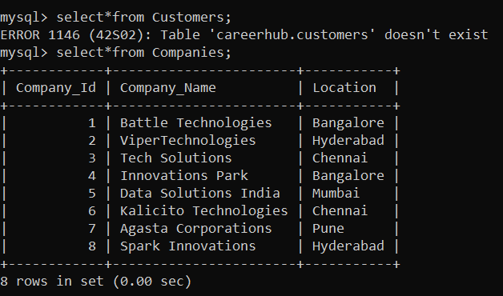

SELECT * FROM Jobs;

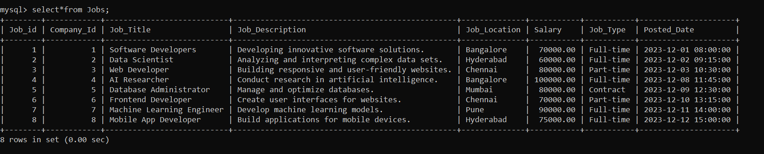

SELECT * FROM Applicants;

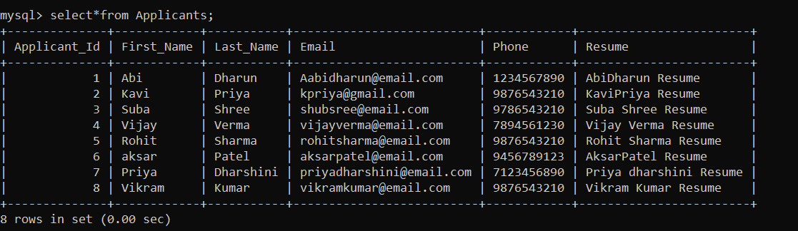

SELECT * FROM Applications;

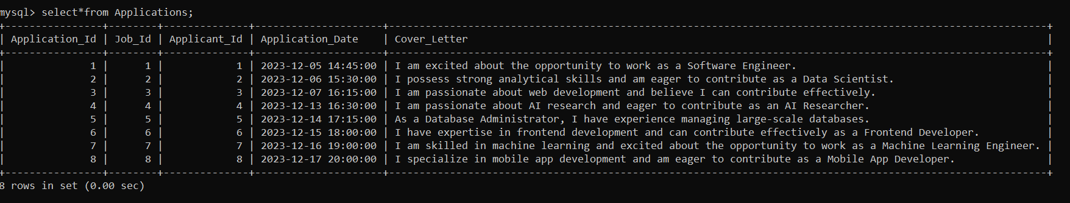

4. script handles potential errors, such as if the database or tables already exist.

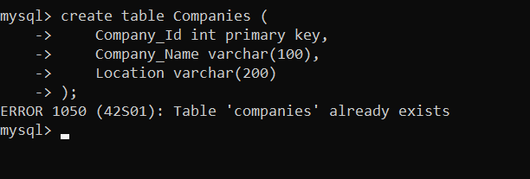

5. Write an SQL query to count the number of applications received for each job listing in the "Jobs" table.

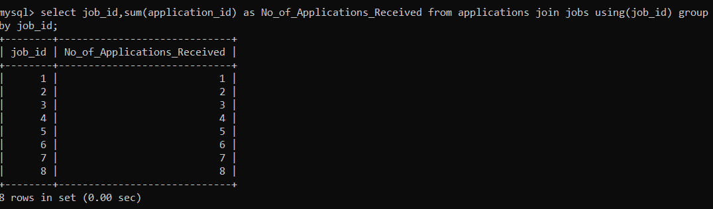

6. retrieves job listings from the "Jobs" table within a specified salary range. Allow parameters for the minimum and maximum salary values. 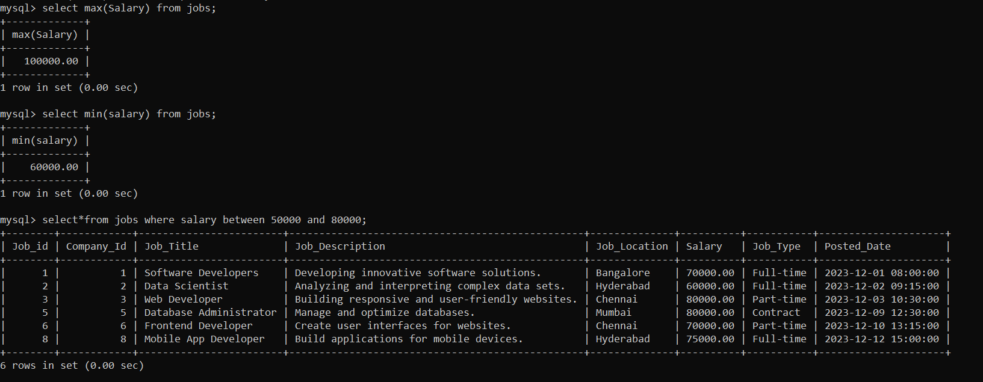

7. Write an SQL query that retrieves the job application history for a specific applicant. Allow a parameter for the ApplicantID, and return a result set

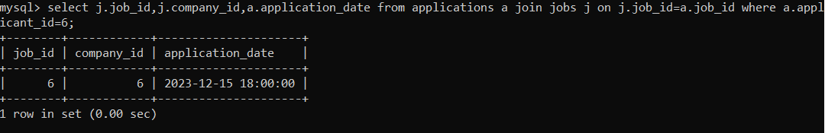

8. Create an SQL query that calculates and displays the average salary offered by all companies for job listings in the "Jobs" table.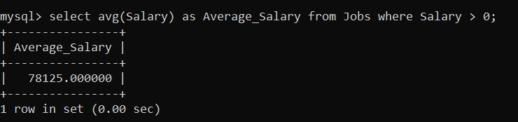

9. Write an SQL query to identify the company that has posted the most job listings.

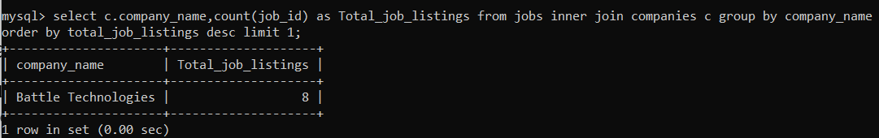

10. Find the applicants who have applied for positions in companies located in 'CityX' and have at least 3 years of experience.

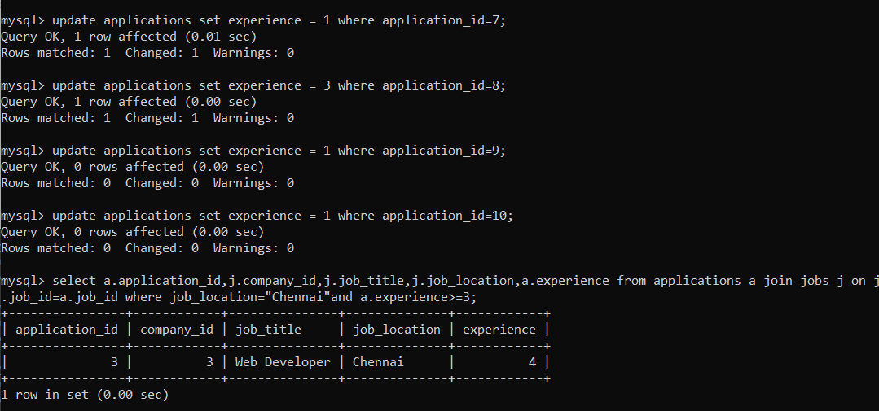

11.Retrieve a list of distinct job titles with salaries between $60,000 and $80,000.

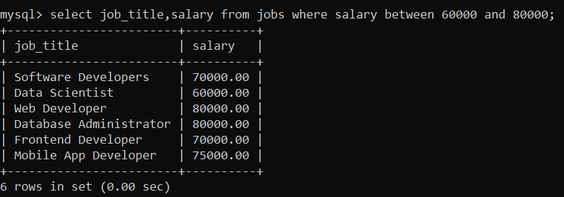

12. Find the jobs that have not received any applications.



13. Retrieve a list of job applicants along with the companies they have applied to and the positions they have applied for.

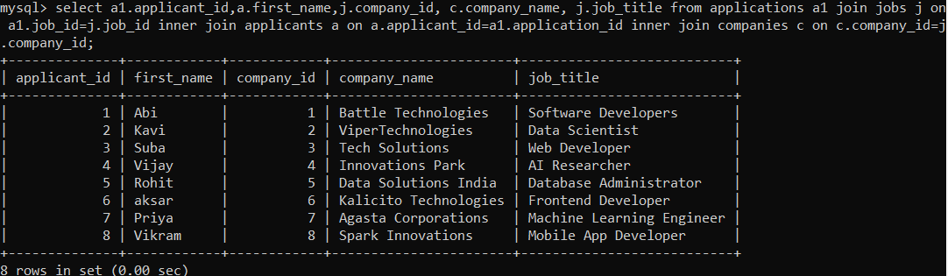

14. Retrieve a list of companies along with the count of jobs they have posted, even if they have not received any applications.

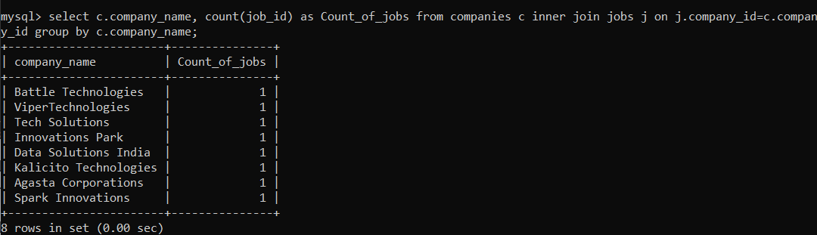

15. List all applicants along with the companies and positions they have applied for, including those who have not applied.

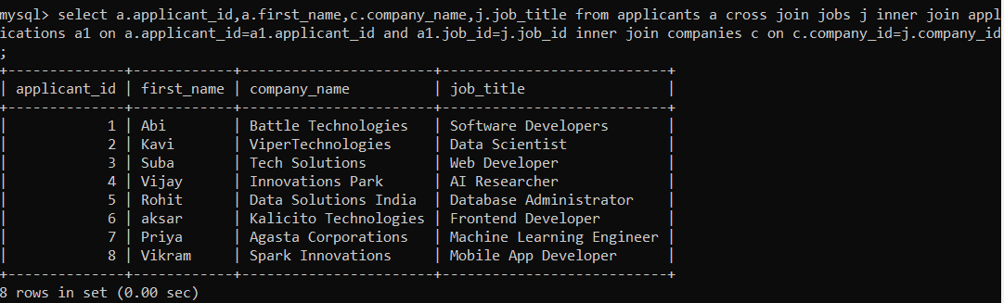

16. Find companies that have posted jobs with a salary higher than the average salary of all jobs.

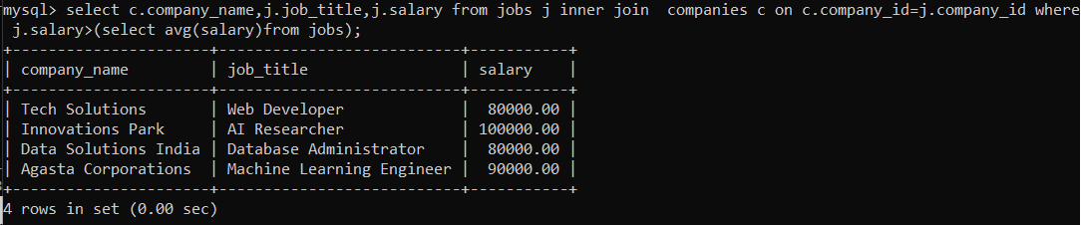

17. Display a list of applicants with their names and a concatenated string of their city and state.

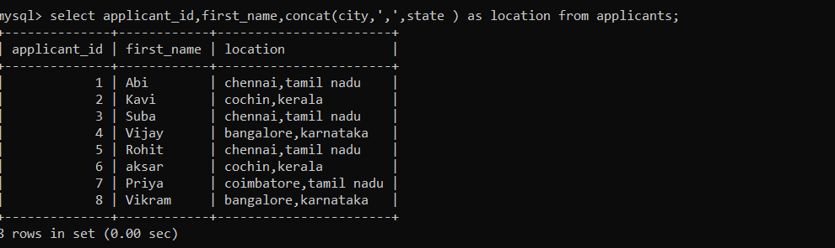

18. Retrieve a list of jobs with titles containing either 'Developer' or 'Engineer'.

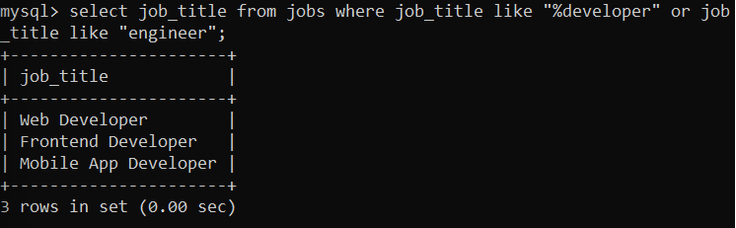

19. Retrieve a list of applicants and the jobs they have applied for, including those who have not applied and jobs without applicants.

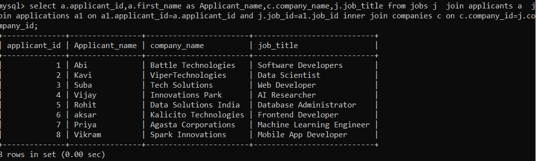

20. List all combinations of applicants and companies where the company is in a specific city and the applicant has more than 2 years of experience. For example: city=Chennai

